**CSCM1010 Content Creation Section 3**

**Doris Montanera**

**Written Content**

**Sneha Raval**

**221064969**

**18 February 2025**

**Part 1: Summary**

Blossom & Bloom Florals is a boutique floral establishment that designs beautiful, heartfelt floral creations for various events. The company aims to distribute fresh premium flowers and boost emotional and aesthetic flower enjoyment in daily life. We practice sustainable practices because we use locally obtained seasonal flowers whenever we can, and we design arrangements that celebrate natural beauty.

Editorial Mission Statement and Brand Personality

Flowers at Blossom & Bloom Florals possess a transformative ability that changes the atmosphere and enhances emotional well-being in addition to expressing feelings. Our editorial focus is training customers about floral value while teaching them flower care and demonstrating ways flowers can add value to their existence.

Brand Personality:

We speak with an inviting tone that combines sophistication with personal style. We deliver meaningful flower knowledge that proves educational while encouraging inspirational creative instincts. Our organization actively supports environmentally safe and ethical floral operations.

Brand Persona

Persona Name: Sophia at age 32, works as an interior designer who maintains a lifestyle blog and enjoys design aspects and self-care activities along with meaningful events. The sustainability principles are essential to her as she adorns her home with fresh flowers from time to time. She regularly buys fresh flowers and tracks home decor patterns through social media platforms while posting her floral ornament arrangements. The brand stands by four essential values, which include beauty mindfulness sustainability along creativity. Her goal involves building a peaceful, breathtaking home setting alongside her objective to gain knowledge about floral design. She faces three main challenges: maintaining durable floral arrangements and more information about plant symbolism as well as sustainable flower options.

The best way to reach her is through Instagram, Pinterest, and lifestyle blogs.

**Part 2: Podcast**

[**Podcast link**](https://drive.google.com/file/d/1CFPEugQV-wOf1z3hZyXhMmRXD2KXh6Sg/view?usp=drivesdk)

**Transcript:**

Anjali: That early exposure made me realize how much joy flowers can bring to people.

Sneha: What's the biggest challenge you faced when you started out?

Anjali: The biggest challenge was learning a business side of floristry.

Sneha: Have you ever wondered what goes into creating the perfect banquet? Today, we uncovered the secrets with the expert florist. Welcome to The Blooming Hour, the podcast where we uncover beauty and the business of flowers.

Sneha: I am Sneha and today we are talking about the behind the scenes of florist's world. From early morning Market runs To crafting a breathtaking banquet, have you ever wondered what it takes to be a florist?

Sneha: Stay tuned because today's episode is packed with insights for flower lover and aspiring floral designer life. I'm thrilled to have Anjali with us today, a passionate florist and creative mind behind the forest of flowers.

Sneha: With the years of experience in floral industry, she had transformed her love for flowers into a thriving business. So welcome to the show.

Anjali: Thank you for having me.

Sneha: Let's dive in. What sparked your interest in floristry? Was there a defining moment that made you realize this was your calling?

Anjali: Absolutely, my grandmother had a lush garden filled with roses, peonies, and lilacs, and I spent like countless hours helping her pick the flowers and arrange them in the vases.

Anjali: That early exposure made me realise how much joy flowers can bring to people. And later on, when I designed my first wedding boutique, I knew this is a path for me.

Sneha: That's such a beautiful story. But running a floral business Isn't just about creativity, it's also required a business equipment. What's the biggest challenge you face when you starting out?

Anjali: Well, great question. The biggest challenge was learning a business side of floristry. Understanding the seasonable availability, pricing, customer service really took time.

Anjali: And I also had to navigate the sourcing, fresh flowers, while maintaining the sustainability as well. But with the time and experience, I found my rhythm.

Sneha: Speaking of sourcing, how do you ensure that you always have the best flower for your clients?

Anjali: I work closely with the local farmers and attend the flower market every morning to handpick the fresh blooms.

Anjali: Sustainability is a priority for me for sure and I try to source in-season flowers and use the eco-friendly packaging which will like reducing the weight is kind of a huge part for my process as well.

Sneha: That's amazing. Sustainability is such an important factor in today's floral industry. Do you have any favourite flower or arrangement style that you love creating the most?

Anjali: Well, it's hard to choose, but peonies in spring and dahlias in the fall are my absolute favourite. For the style, I love organic garden inspired arrangements, and which feels like natural and effortless.

Sneha: Your passion really shines though. Before we wrap up, what advice would you like to give to someone who is aspiring to become a florist?

Anjali: Well, I would say start with the passion first, but also develop your business skills, Find a mentor, practice daily, and experiment with different styles. And most importantly, remember that flowers are about storytelling. Each arrangement should evoke the emotions.

Sneha: Such great advice. Thank you so much, Anjali, for joining us and listeners if you want to see Anjali's work. Here's her handles and the website. You can see her work.

Anjali: Thank you for having me.

Sneha: My pleasure. Hope you had a great time. That's all for today's episode, The Blooming Hour. If you enjoyed this conversation, don't forget to subscribe and share this episode with your fellow followers. And for more tips, visit our new latest blog post. Until next time, keep blooming.

**Part 4: Instagram Post**

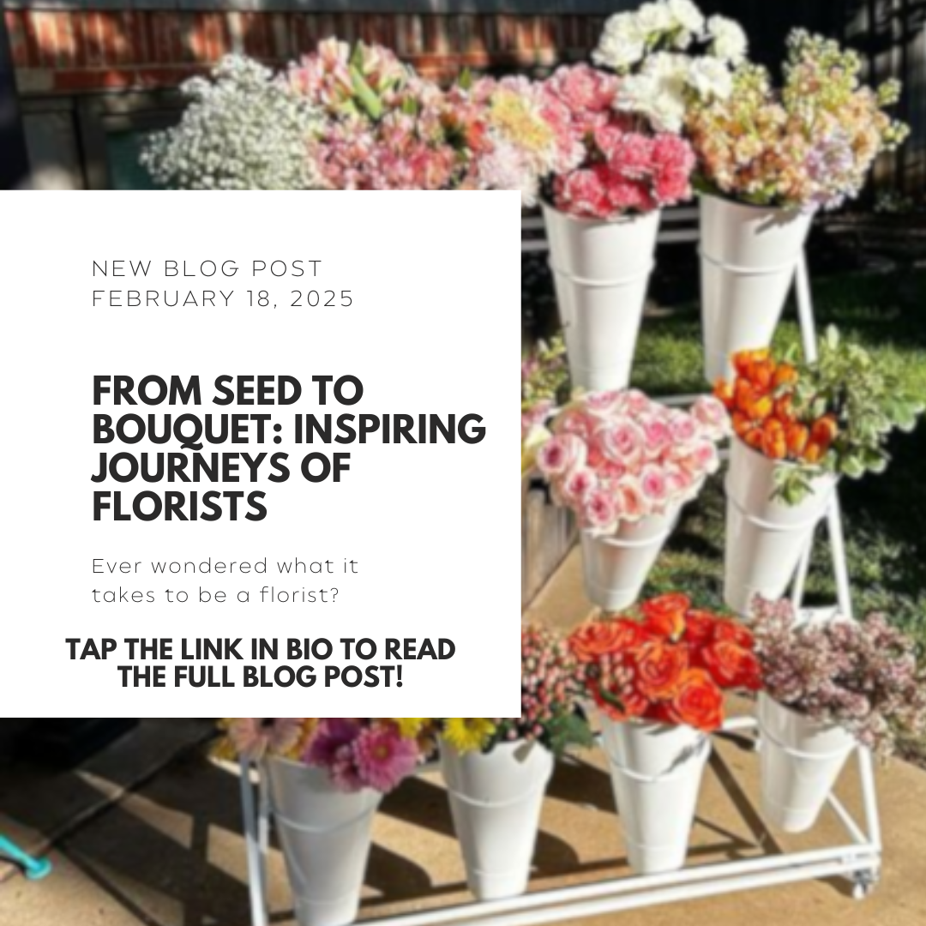

**Caption:**

Have you ever wondered what it takes to be a florist? In our latest blog post, we take you behind the scenes of a florist’s journey. Read the full story by Clicking the link in the bio to explore the art and business of floristry.

#FloralDesign #FloristLife #BloomingHour #SustainableFloristry #FlowerPower #FloristTips

Appendix

[Anjali-florists](https://www.linkedin.com/in/anjali-florists-213ab292/?originalSubdomain=in)

[forestofflowers](https://www.forestofflowers.com/locations/burlington-ontario/5010-pinedale-ave)